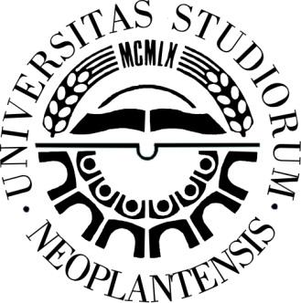
CONFERENCE 2022 – CHANGING PARADIGMS IN EDUCATION AND SCIENCE
University of Novi Sad
Hungarian Language Teacher Training Faculty in Subotica, Serbia
REGISTRATION
CONFERENCE (*choose one)
16th INTERNATIONAL SCIENTIFIC CONFERENCE  inter.conf@magister.uns.ac.rs | 11th INTERNATIONAL METHODOLOGICAL CONFERENCE  method.conf@magister.uns.ac.rs | 9th ICT IN EDUCATION CONFERENCE  ict.conf@magister.uns.ac.rs
Language of presentation: | Serbian / Hungarian / Croatian / English / Other:
Language of study: | Serbian / Hungarian / Croatian / English / Other:
CORRESPONDING AUTHOR
first and last name:
e-mail:
AUTHOR(S)
1st author
first and last name:
expertise:
e-mail:
institution (name):
institution (city):
institution (country):
2nd author
first and last name:
expertise:
e-mail:
institution (name):
institution (city):
institution (country):
3rd author
first and last name:
expertise:
e-mail:
institution (name):
institution (city):
institution (country):
4th author
first and last name:
expertise:
e-mail:
institution (name):
institution (city):
institution (country):
5th author
first and last name:
expertise:
e-mail:
institution (name):
institution (city):
institution (country):

SUMMARY
Title:
Summary
(max 1000 characters):
Keywords
(max 5):

Privacy policy
Data processing agreement

In assessing the appropriate level of security, Hungarian Language Teacher Training Faculty in Subotica shall take account of your personal data and comply with all applicable elements of the Serbian Personal Data Protection Law (Official Journal of RS no.87/2018, 104/09-law, 68/12-decision and 107/12). We will not use, process, transfer or forward your personal data to third parties (either persons or companies) without your consent, except for cases indicated in the Law: these are cases in which your consent is not needed (e.g. in life- or health saving situations, obligations set in legal acts, contracts or preparation of the latter, with the aim of collecting means for humanitarian purposes or in other cases according to the Law).

By signing this Personal Data Processing Agreement you agree that you personal data may be used, processed, transferred or forwarded by the Hungarian Language Teacher Training Faculty in Subotica.

You also agree that we contact you and add your contact to our mailing list – you get on the mailing list only after giving your consent to it, and you also agree that your email, your institution and work be used in our book of abstracts as well as our publication of conference papers available on the web-page of our Faculty. Your personal data protection is permanent and you can redraw from the Agreement at any time. You may also ask for amandment or correction of your personal data or deleting your contact from our mailing list. After that, your personal data will not be used any longer by the Hungarian Language Teacher Training Faculty in Subotica, except for internal usage, e.g. as IT or statistical data and these are no longer usable for the identification of the person they refer to.

If you have any question about the processing of personal data or if you want to redraw from this Agreement for any reason and any time, as well as if you wish to correct you personal data, please write us (via post, fax or email): gdpr@magister.uns.ac.rs

***
In case you no longer want to receive emails about our conference, please send a note via email, and we will delete your contact from our mailing list.

